EXAM B

1)

- Parking Lot – Capacity of the system!

R= I/T

I= (100*1.5)

(We need to calculate the average time they spend inside)
T= 0.25* (30/60) (Percentage of people that only delivers books) + 0,75*2h
T= 1,635h

R= [(100*1.5) / 1.635] * (1/0.5) = 184,6 people/h

If you don’t consider * (1/0.5), then all you have is the Local capacity!

B) Reading Area

R = I/T

T= 2h

I= 200*2

R= [(200*2)/2] * (1/0.75) =266,6 people/h

C) Cafeteria – 75% of the people will use them
And since they spend 2h there, they will visit it twice per hour (2/h)

We know the Parking Lot is the bottleneck

So from the 184,6 - 75% will visit the cafeteria

184,6 * 0,75 = 138.45 * 2 (because they visit it twice in an hour!)

C (=R) = 276,9

2) M/M/1 (Different waiting lines)

Available Info:
BOYS: Wq = 1,5m

GIRLS:
λ = 50/h
μ = 2m = 60/2 = 30/h

Wq (for girls) = (1+2/3) * 1,5 = 2,5 m
Wq < 2,5m
(The Wq for girls has to be equal or smaller than 2m)

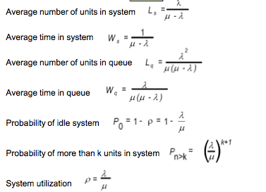

1 Toilet
Wq = 50 / (30 * (30-50) = < 0 – Invalid system

2 Toilets

μ = 2m = 60/2 = 30/h (Remains the same)
But there are two equally distributed lines so:
λ = 50/2 = 25/h

Wq = 25 / (30 * (30-25) = 0.16667 * 60 = 10 > 2 (Doesn’t work

3 Toilets

μ = 2m = 60/2 = 30/h (Remains the same)
But there are three equally distributed lines so:
λ = 50/3 = 16,667/h

Wq = 16,6667 / (30* (30-16,6667) = 0.04166675* 60 = 2.5

There should be three bathrooms

3) P system

a) SS = Z96% * $σ$ L+T

SS= 1,75 (Taken from the Table) * $\sqrt{L+T}$ *$σ$

SS = 1.75 * 4 *10 = 70, 027

Holding Cost of SS = SS * 100/month * 12months/year = 70,027*100*12 = 84032,4

b) 15 * 20 = 300

(Pergunta mais ridicula de sempre… Nem sei se percebo bem. Basicamente é o tempo entre pedidos vezes a media diária de cada pedido…)

c) Why? Because demand is not constant.
(Ela disse na aula que isto bastava…)

4)

Z2000 = (2000-1500) / 250 = 2 (Table = ) 0.9722 (A)

Z1250 = (1250-1500) / 250 = -1 (Table =) 1-0.8413 (B)

( 1250 < X < 2000) = (A)– (B) = 0.8135

0.8135*2000 =1637,8

